

Digital Menu Application For Accessibility In Restaurants

Final Year Project Report

DT282

BSc in Computer Science International

### Angela Peng

### Oisin Creaner

### School of Computing

### Dublin Institute of Technology

### <Date>



Abstract

Declaration

I hereby declare that the work described in this dissertation is, except where otherwise stated, entirely my own work and has not been submitted as an exercise for a degree at this or any other university.

Signed:

_________________________

<Student Name>

<Date>

Acknowledgements

Body text

Table of Contents

1. Introduction 9

1.1 Project Background 9

1.2 Project Description 9

1.3 Project Challenges 10

1.3.1 Appropriate API Libraries 10

1.3.2 Firebase Backend 11

1.3.3 Accessible User Interface Design 11

1.4 Project Objectives 11

1.5 Structure of The Document 12

1.5.1 Chapter 2 – Research 12

1.5.2 Chapter 3 – Design 12

1.5.3 Chapter 4 – Architecture & Development 12

1.5.4 Chapter 5 – System Validation 12

1.5.5 Chapter 6 – Project Plan 12

1.5.6 Chapter 7 – Conclusion 12

2. Research 13

2.1 Background Research 13

2.2 Similar Technologies 14

2.2.1 Order Wizard 14

2.2.2 Quick Orders 15

2.3 Technologies Researched 17

2.3.1 Front End Development (Native, Web, Hybrid) 17

2.3.2 Back End Research (Firebase, PHP, SQLite) 17

2.3.3 Application Programming Interface and Libraries 18

2.3.4 Customer Relationship Management (CRM) 18

2.3.5 Localizing User Interface 18

2.3.6 PayPal 19

2.3.7 Vision Impairment 19

3. Design 20

3.1 Methodology 20

3.1.1 Agile Methodology 20

3.1.2 User-Centred System Design Methodology 21

3.2 Use Cases and Iterations 22

3.2.1 The First Iteration 22

3.2.2 The Second Iteration 25

3.2.3 The Third Iteration 26

3.2.4 Use Case Scenarios 29

3.2.4.1 Scenario A 29

3.2.4.2 Scenario B 29

3.3 Project Structure 30

3.3.1 UI Components of Client Application 30

3.3.1.1 Layout Structure 30

3.3.1.2 Experience Designer 31

3.3.1.3 Colour Blind Accessibility 32

3.3.2 UI Components of Server Application 32

3.3.2.1 Layout Structure 32

3.3.2.2 Experience Design Server App 33

3.3.3 Package Structure 35

3.3.3.1 Package Structure of Client App 35

3.3.3.2 Package Structure of Server App 36

3.3.4 Migration to Android Jetpack 36

4. Architecture & Design 37

4.1 System Architecture 37

4.1.1 Third Party APIs 37

4.1.1.1 ZXing Barcode Scanner 37

4.1.1.2 RetroFit2 REST API 38

4.1.2 Model View Controller (MVC) 38

4.1.3 Back End Components 40

4.1.3.1 Firebase 40

4.1.3.2 SQLite DB Browser 40

4.2 Code Components of Client Application 41

4.2.1 Activities 41

4.2.1.1 AboutActivity.java 41

4.2.1.2 BasketActivity.java 41

4.2.1.3 HomeActivity.java 41

4.2.1.4 LoginActivity.java 41

4.2.1.5 MainActivity.java 41

4.2.1.6 MenuDetailActivity.java 41

4.2.1.7 MenuListActivity.java 41

4.2.1.8 OrderPlacedActivity.java 41

4.2.1.9 ProfileActivity.java 41

4.2.1.10 ScanActivity.java 41

4.2.1.11 SearchFoodActivity.java 41

4.2.1.12 SeeReviewsActivity.java 42

4.2.1.13 SignUpActivity.java 42

4.2.2 Adapter 42

4.2.2.1 BasketAdapter.java 42

4.2.3 Config 42

4.2.3.1 RemoteAPIService.java 42

4.2.3.2 RetroClient.java 42

4.2.4 Control 42

4.2.4.1 Control.java 42

4.2.4.2 Paypal.java 42

4.2.5 Database 42

4.2.5.1 Database.java 42

4.2.6 Helper 43

4.2.6.1 NotifyMeHelper.java 43

4.2.7 Holder 43

4.2.7.1 MenuHolder.java 43

4.2.7.2 OrderHolder.java 43

4.2.7.3 ProductHolder.java 43

4.2.7.4 RestaurantHolder.java 43

4.2.7.5 ReviewHolder.java 43

4.2.8 Interaction 43

4.2.8.1 FirebaseMessage.java 43

4.2.8.2 FirebaseService.java 43

4.2.9 Model 43

4.2.9.1 MakeOrder.java 43

4.2.9.2 Menu.java 43

4.2.9.3 Notification.java 43

4.2.9.4 Order.java 44

4.2.9.5 Product_Type.java 44

4.2.9.6 Response.java 44

4.2.9.7 Restaurant.java 44

4.2.9.8 Result.java 44

4.2.9.9 Review.java 44

4.2.9.10 Sender.java 44

4.2.9.11 Token.java 44

4.2.9.12 User.java 44

4.2.10 View 44

4.3 Code Components of Server Application 44

4.3.1 Activities 44

4.3.1.1 AboutActivity.java 44

4.3.1.2 HomeActivity.java 44

4.3.1.3 MainActivity.java 44

4.3.1.4 MenuListActivity.java 44

4.3.1.5 OrderDetailActivity.java 44

4.3.1.6 OrdersPlacedActivity.java 44

4.3.2 Adapter 44

4.3.2.1 ExtraDetailAdapter.java 45

4.3.3 Config 45

4.3.3.1 RemoteAPIService.java 45

4.3.3.2 RemoteClient.java 45

4.3.4 Control 45

4.3.4.1 Control.java 45

4.3.5 Helper 45

4.3.5.1 NotifyMeHelper.java 45

4.3.6 Holder 45

4.3.6.1 MenuHolder.java 45

4.3.6.2 OrderHolder.java 45

4.3.6.3 ProductHolder.java 45

4.3.7 Interaction 45

4.3.7.1 FirebaseMessage.java 45

4.3.7.2 FirebaseService.java 45

4.3.8 Model 45

4.3.8.1 MakeOrder.java 45

4.3.8.2 Menu.java 45

4.3.8.3 Notification.java 45

4.3.8.4 Order.java 45

4.3.8.5 Product_Type.java 45

4.3.8.6 Response.java 45

4.3.8.7 Result.java 45

4.3.8.8 Sender.java 45

4.3.8.9 Token.java 45

4.3.8.10 User.java 45

4.3.9 View 45

1. Introduction
   1. Project Background

The aim of this project is to assist individuals and businesses with flexible communication in the workplace. Ordering food through an application can be of great efficiency for both users and businesses with the aid of technology. This application can assist users that may have anxiety in social environments to feel comfortable and enjoy their time at a restaurant without the need to interact directly with a waiter. The real-time notification interaction between users and business provides a firm bridge of communication. Kitchen staff that can see orders placed are able to determine when the order is available to be served, this can be of great advantage to both customer and staff. The data from orders allows customers to keep on track of time and allows staff members to manage their business. This project will consider many ways of user accessibility in design, implementation and development. A key feature to this project for efficiency is the use of QR codes. QR codes or also known as Quick Response codes have existed for over 15 years. Quick Response codes were first introduced by Denso Wave during 1994. It was used to enhance decoding speed and the ability to hold large amount of information. QR codes not only has the function of holding data but it is also a great marketing tool to draw in tech savvy audiences.

Internationalisation is a problem we face on a daily basis, with the aid of technology we are able to break that language barrier. By implementing a language setting into this application, we are giving a chance to open up the many possibilities of internationalisation. Allowing multiple languages can be of great benefit to broaden the business into the global market.

* 1. Project Description

This project will be divided into three parts, Client, Server and Administrator. A diagram shown below a summary explanation of the overall application.



Client application uses many API libraries to perform tasks such as reading QR code, make order, make payments through the application and receive live updates on order status. Users can make payments through the app after an order is placed. Payments can be received by PayPal, credit card or cash transactions. Once the order is placed the details of the order is sent to the kitchen (Server Application). Here the restaurant staff are able to control the server side functionalities.

Server application will be able to manage order status and restaurant menus. Restaurant staff are able to receive a notification, notifying them of new orders, payment methods and extra details the customers may have noted in their order. Restaurant managers are able to add new dishes, edit current dishes and view orders.

Administrators are able to oversee all functionalities from the front and back end. They can provide new updated versions, fix bugs and setting up new restaurants and staff.

* 1. Project Challenges

There were many challenges faced during the development of this project. Below are some of the major challenges and issues that were encountered.

* + 1. Appropriate API Libraries

Choosing a precise API for certain functionality was a challenge as there are both pros and cons that needs to be considered. While choosing a third-party barcode scanner there where many libraries to choose from. Google Mobile Vision and ZXing barcode scanner were the top two APIs that were examined for this project. At the end ZXing API was chosen because of its simplicity in use compared with google vision.

* + 1. Firebase Backend

With a lack of knowledge on firebase, going back and forth between different backend services slowed down a significant amount of time in the development phase. This caused a great challenge. But with determination of producing real-time data and notification services, Firebase was the best service to implement.

* + 1. Accessible User Interface Design

To implement a user-friendly interface that is accessible to users with colour blindness, choosing a colour palette was a great difficulty. Considering the different types of colour blindness and its statistics, deuteranomaly is one of the most popular kind which is a reduced sensitivity to green light. Research shows that one in twelve men are colour blind. After testing out different colour combinations with a colour blind tool a simple solution is to set the contrast of colours and text to a 4.5:1 ratio.

* 1. Project Objectives

The main objective of this project is to create an interactive order management system with the aid of QR codes. By using QR codes we are able to retrieve data efficiently from our backend firebase. Not only is this project focuses on the use of QR code but also allow users to integrate different languages whether for educational purposes or translation purposes. This application has the ability to implement different languages

* 1. Structure of The Document
     1. Chapter 2 – Research

In this section, research in background, similar applications and technologies are conducted.

* + 1. Chapter 3 – Design

In chapter 3, the design implementation is discussed and how complementing colours play a major visual impact for colour blind users.

* + 1. Chapter 4 – Architecture & Development

This section, the architecture and implementation is discussed backed up with sample codes.

* + 1. Chapter 5 – System Validation

Testing will be conducted by users of little technical knowledge and tech savvy users.

* + 1. Chapter 6 – Project Plan

This section discusses the projects life cycle and any changes that were made during the course of this piece of application.

* + 1. Chapter 7 – Conclusion

To conclude, a reflection of the overall project, future plans and learning curve are discussed.

1. Research
   1. Background Research

For a business, it is important to understand its market and acknowledge the connection with its consumers. Flexibly is the key to a successful business, by implementing technology into the food and drink industry we are able to establish this connection. An application that captures user detail and functions subjected to flexibility like diary free, gluten free, vegetarian or vegan. We can build a trusted foundation between the producer and consumer.

Point of Sale (POS) systems contains tools that are essential to businesses that handles sales reporting, customer management, Inventory management and employee management. POS can provide store manager with information that increases business efficiency.

T

* 1. Similar Technologies
     1. Order Wizard



Order Wizard has similar functions to this project including QR code scanning and processing payments through the application. This application supports both android and IOS system. The system will ask the user to scan a QR code to retrieve a restaurant, then depending on the restaurant a menu will display. From the menu, the user is able to add items to order, when they are finished they can then edit, delete or add extra details. Payments are compensated by PayPal, offline cash or offline card transaction.

A benefit that this application take is users can call the waiter if they want to process the transaction with cash.

A disadvantage is that any extra details that the user adds is not by item but by the overall order. This application also does not ask for customer details this may cost a loss in clientele and security breach. User authentication provides secure transactions and personal information without this it becomes a vulnerability. The system will become exposed to cybercriminals from gaining personal information.

This application is available on google play but there haven’t been any updates since 2013 when the application was first created. The overall UI appearance is also out dated with a harsh black background and little creativity in design.

* + 1. Quick Orders



This application is available on the google store and it has the functionality of a barcode scanner that supports all mobile operation systems. Similar to this project it has the ability to order through the application, add personal comments and see order histories. A key feature to this application is the multilingual functionality which is a great accessibility characteristic. With this feature, this application can be opened up to a larger global market.

A major advantage of this application is that it is multilingual. Being able to change and set the language according to the user. This feature provides access to users internationally which can help enterprises and businesses to expand their market globally.

A downside to this application is that there is no payment transaction through the app. Once the user places an order it doesn’t ask for confirmation which means any individual that has access to the QR code can make an order and not pay for it, this is a major flaw in the application. If the developer implemented a payment process it can allow quick transaction process and increase user authentication.



The image above shows merchant side application which complements the customer app. This Quick Order Operator shows restaurants or bars of incoming orders.

A disadvantage to this application is no order management or business management which is not as accessible for merchants.

* 1. Technologies Researched
     1. Front End Development (Native, Web, Hybrid)

Developing a front-end user interface, I considered the use of native, web and hybrid application. Below discusses its pros and cons of utilizing these three types of front-end development.

As this project is concerning the development of an android application, android API’s native contains many tools that can be directly accessed through the IDE. For android studio, it be dependent on XML files for activities. Fast and responsive. As the application is native to its platform, data is fetched from a web server rather the application. Internet access is not an essential requirement, though some application do expect to use it. Specific UI design for an overall better user experience. More interactive experience because they are running on the device built-in features. Runs much smoother for user input and output. Need an extensive amount of knowledge in the programming language during development and maintenance. Native apps need constant software updates to fix any bugs. Needs vast amount of time to implement with the large amount of work that is expected to develop a native application the cost sequentially increases

Web application hosted by web browsers are condensed information from the website to produce a more functional application. A wide range of technologies can be used to implement a web application this includes, open source platforms like PHP or MYSQL. Easy to maintain without user having to constantly update the application. Accessible to all platforms through an internet connection which allows cross-platform application service. Security is a priority in web applications. Unlike other simple websites, web applications are utilized on the machines dedicated server. Needs internet access at all time, without it users cannot experience the application to its full potential. Much slower than native apps. Less interactive for client side.

Hybrid applications is a combination of a native app and a web app. Built using JavaScript, HTML, CSS wrapper in a native container like, web view. Easy to develop and time for development is significantly faster than native apps. Allows access to different device platforms to be integrated this is cost efficient. Consistent maintenance can be done without having the user update the application expect for any major changes. Much slower than native apps. Less interactive, navigation to different activity could be lagged. Cannot experience access to native features, this can be a downfall for UI design and programmatic operations.

* + 1. Back End Research (Firebase, PHP, SQLite)

Cloud hosted services which can used by application development as a backend server. Firebase offers many abilities to perform client-server interaction. Offers storing and synchronising real time data to any connected devices of all platform. Offers the use of google analytics. Easy to implement with little back end development. Can implement many ways to authenticate users including email and password, Facebook, google account authentication. Making developing apps identifying users efficiently. Allows notifications to be sent to targeted users using the notification console GUI. This is a free service that firebase provides. Usage limitations, firebase free version only allows up to 50 connections. Doesn’t work like ordinary relational DBMS. Therefore, normal SQL queries are no use in firebase

SQLite is an open source database service and it can be accessed using android studio IDE. No installation is required for this database service because it is an in-process relational DBMS. Lightweight structured file using query language, SQL to retrieve data. Doesn’t rely on server which means no configuration is required and can be portable. Communicates directly with the application for this instance Android studio IDE. Can only handle low to medium traffic which is not suitable for large data storing application. Scalability limitations

* + 1. Application Programming Interface and Libraries

With the introduction of google play service 7.8, Mobile vision API released a new API which enables barcode scanner to read and decode its contents. Google barcode API is able to detect barcodes in real time on devices in any orientation. Implementing this with permission to use Camera API, an android framework which supports various camera features. Allows the application to access the device camera and scanning any barcode it detects.

ZXing also known as “Zebra Crossing” is a google operated open source service which is used to read and decode barcodes using an image processing library.

* + 1. Customer Relationship Management (CRM)

Mobile customer relationship management (CRM) is extremely important in today’s business industry. With the increase in the use of technology and internet services businesses ensures customers are receiving the best service at all time. Capturing client details allows employees to provide real-time data and information to clients immediately.

Benefits of customer relationship management is its ability to deliver performance reports, analytics in sales and organizational activities in businesses.

* + 1. Localizing User Interface

Advancement of technology made it possible to communicate with individuals of different nationality to interact with each other at ease. For instance, if a user that has many allergies is travelling and ordering food in a foreign restaurant becomes a difficulty an application that supports different languages can benefit these individuals. Therefore, the language barrier is not a problem when customers go to a non-English spoken country.

Android studio is able to localize the user interface to support different languages. By utilising translation editor in the IDE, it will allow the application to change from one language to another and not effecting the systems default language.

* + 1. PayPal

The most secure way of electronic transactions is through PayPal. Paypal accepts payments using credit card and PayPal account transactions. By using HTTP based RESTFUL APIs, we can retrieve real-time data to authenticate credentials. Responses and requests are structured in JSON.

* + 1. Vision Impairment

There is an estimate of 285 million people globally who are vision impaired. Developing an application that allows flexibility and change in user interface can ease any conflict and intimidation for individuals with vision impairment.

Colour schemes, amount of information displayed and navigation should all be considered when developing.

1. Design
   1. Methodology

There are many different methodologies that are available to conduct a successful project management and product. Methodology itself is defined to be a system of methods used in a particular area of study or activity. Below discusses the two main methodologies that are implemented into this project:

* + 1. Agile Methodology



The agile methodology is a method that provides quick and responsive feedback to developers in the direction the project is headed. During the development phase it has many opportunities to asset the project. The agile manifesto have four fundamentals values that are considered:

1. Individuals and interactions over processes and tools
2. Working software over comprehensive documentation
3. Customer collaboration over contract negotiation
4. Responding to change over following a plan

By implementing some aspects of agile methodology and principles, a valuable product was developed in a time efficient and organised manner. Agile process is customer focused and aligned with business needs.

* + 1. User-Centred System Design Methodology



User-Centred System Design (UCSD) methodology’s focal point is usability throughout the entire development cycle and how it impacts users. Usability measures the productivity of the product and its efficiency and satisfactory to a targeted audience. There are ten key principles of UCSD to remain focused on usability:

1. Design for the users and their tasks
2. Maintain consistency
3. Usage of simple and natural dialogue
4. Reduce unnecessary mental effort by users
5. Provide adequate feedback
6. Provide adequate navigation mechanism
7. Let the user take charge
8. Present information clearly
9. Offer assistance
10. Error-free

While developing this application all of the above principles are implied, especially when designing the user interface. This was a challenge and countless of research and tests were conducted. Focusing on the accessibility usage for users many aspects to the visuals were considered. By following the path of UCSD a clear visual and navigation mechanism was designed.

* 1. Use Cases and Iterations

This section comprises of use case diagrams, sequence diagrams and their corresponding iterations. I think that this is a simple way to understand each actors’ roles and what the system entails in a sequential order.

* + 1. The First Iteration

The first iteration includes actions customers are able to perform when using this application. The process of customer upon registering and making an order will involve at least 2 actors, the customer itself and the restaurant staff.

|  |  |
| --- | --- |
| Main Flow of First Iteration | |
| 1.1 | Customer creates account |
| 1.2 | Customer allows application to access device camera to scan QR code |
| 1.3 | Customer can view menu |
| 1.4 | Customer makes order |
| 1.5 | Customer view status of their order |
| 1.6 | Waiter can view new orders |
| 1.7 | Managers can view menu |

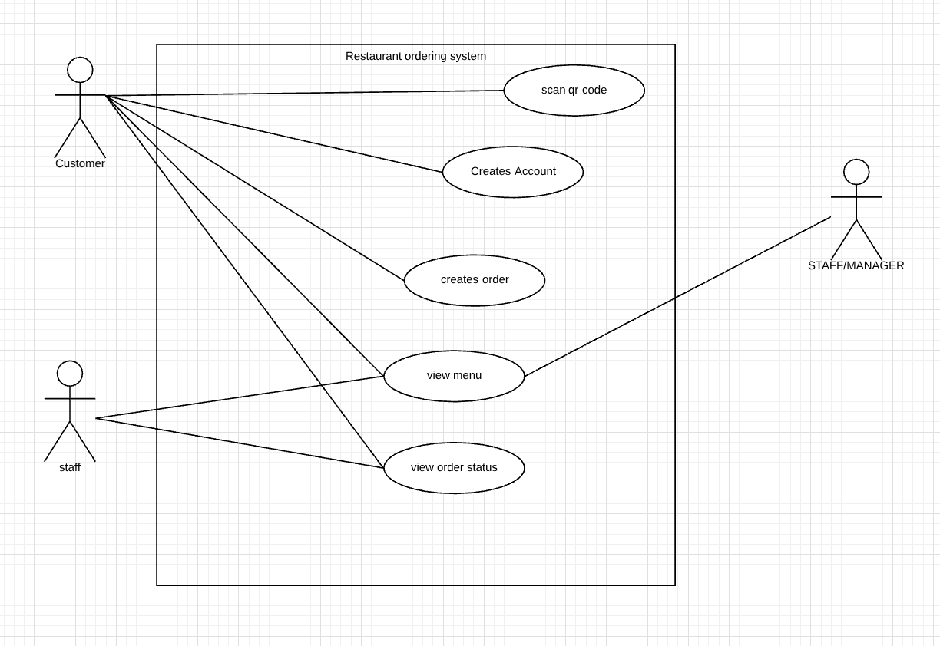

|  |  |
| --- | --- |
| Conditions of First Iteration | |
| Description | From the first iteration, we can see that the Customer is able to scan QR, create account, create order, view menu and view order status. The staff actor is consisting of waiters and chefs. |
| Pre-Condition | We know nothing about the user. |
| Post-Condition | We know information about the user, we know their allergies and we know if they have a vision impairment. |
| Exception Errors | The user may only use card transaction when using this application. |
| Alternative variations | Users are validated by unique phone number and a corresponding password. |

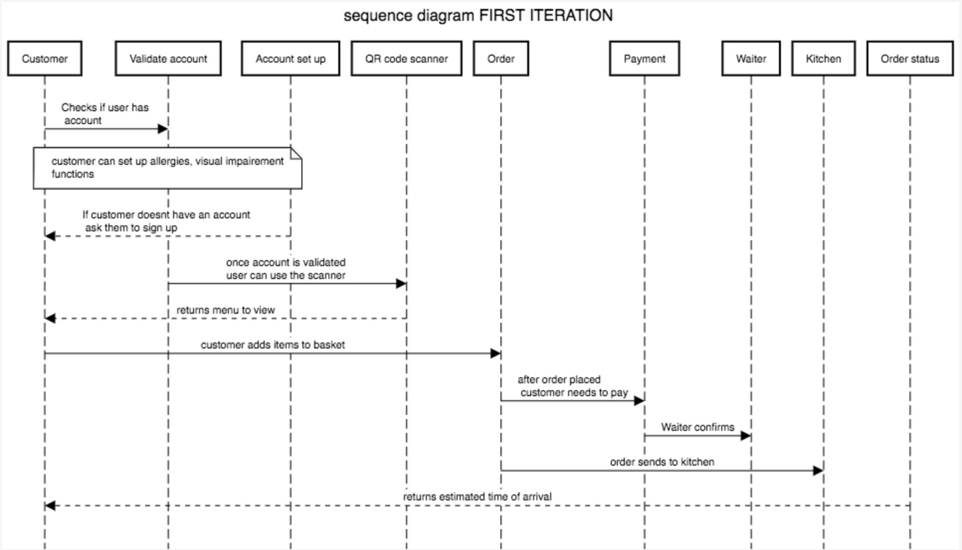

This sequence diagram shows the sequence of actions performed by the customer when using this system. The user upon using the application must log into an already existing account or create a new account. The user inputs will be validated based on firebase authentication on email and password. Once the user is able to access their account they are able to use the QR code scanner. They must first allow the application access to their mobile device camera to perform the camera function. After scanning the QR code, the activity page will show the restaurant menu from here the user can add items on the menu into their basket to add to the order. Once the user is finished with their order they must pay the total amount that is owed before the order goes to the kitchen. The application will ask the user permission to enter card details. Subsequently, the transaction is successful order will be sent to the kitchen staff and waiter. The user from here will be able to see the estimated time of arrival to their table.

* + 1. The Second Iteration

Second iteration is the actions performed by waiter/kitchen staff actor. They have limited access to information about the restaurant itself and customers. Another actor that is involved in the second iteration is the administrator. Administrators has unlimited access, they would know a certain amount of knowledge regarding how the system works and are able to perform maintenance and updates to the software when needed.

|  |  |
| --- | --- |
| Main Flow of Second Iteration | |
| 2.1 | Staff depending on their role a waiter can view transaction and order |
| 2.2 | Kitchen staff can view order only |
| 2.3 | Administrator performs system maintenance |

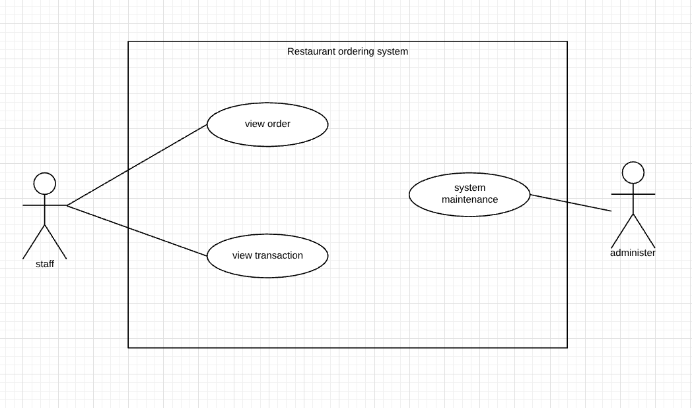

|  |  |
| --- | --- |
| Conditions of Second Iteration | |
| Description | The second iteration shows the staff and administrator. The staff can see the order placed by customers and transaction progress. Administrators maintains the system and keeps the system updated. |
| Pre-Condition | Each staff are given roles by manager, we know information about each staff. We know information about the administrator. Staff doesn’t know customer orders. |
| Post-Condition | Waiters are able to see order after customer has placed one. |
| Exception Errors | The chef can only see the order if the transaction process is completed. |
| Alternative variations | Waiter and chef must log into the staff account, role and position is saved. |

* + 1. The Third Iteration

The third iterations involve the manager of the restaurant only. They also have unlimited access to information about everything in the business. They are able to perform the CRUD operations to menu items, manage employees, manages stocks and review analytic reports. The manager runs the restaurant therefore, have the ability to control the environment.

|  |  |
| --- | --- |
| Main Flow of Third Iteration | |
| 3.1 | Managers can add new items to the menu |
| 3.2 | Managers can delete items from the menu |
| 3.3 | Managers can edit items on the menu |
| 3.4 | Managers can view order history |
| 3.5 | Administrator performs system maintenance |
| 3.6 | Managers manages stock |

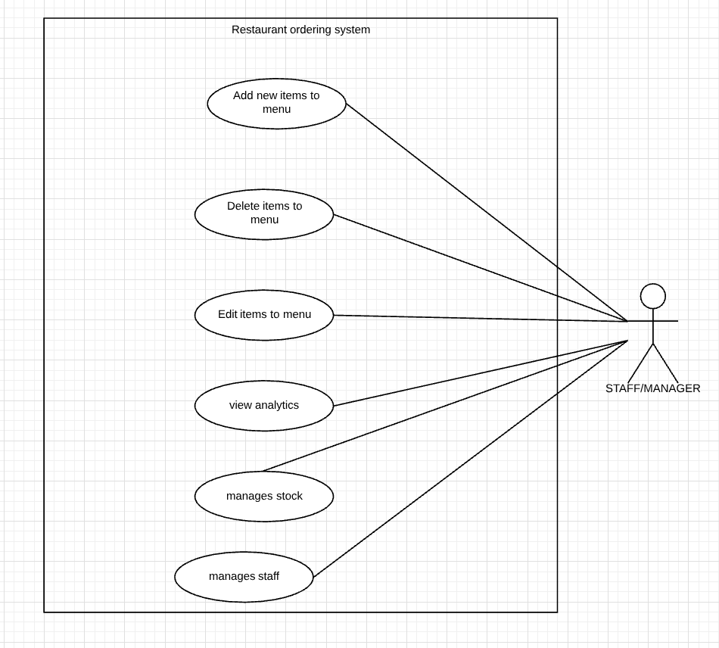

Description: The third iteration will contain the details of roles the restaurant manager. The manager can create, view, update and delete menu items. Managers are also responsible for staff management and stock management. By capturing customer details in the first iteration managers can view weekly, monthly and annually analytics of target sales.

Pre-condition: Managers knows information about menu, staff and products.

Post-condition: Managers can view targets and what products needs to be ordered.

Exceptional Errors: Manager is the only one who can view the analytics

Alternative Variables: Manager logs into staff page, the role and position must be clearly stated

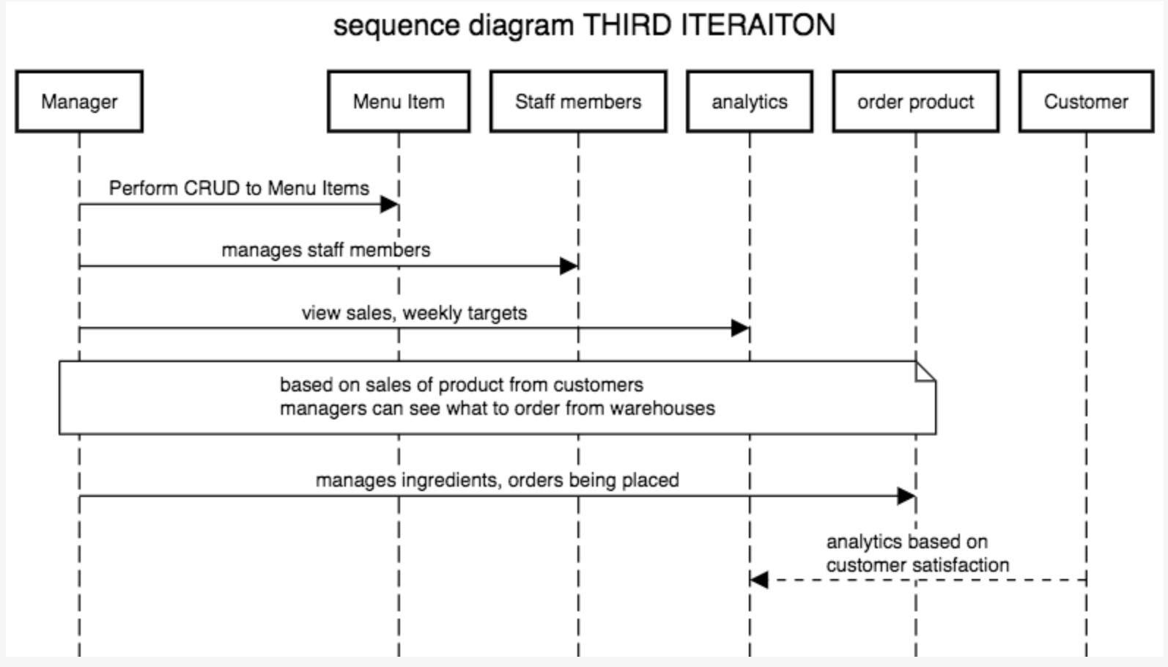

Managers can perform create, read, update and delete (CRUD) operations on menu items. Managers can manage staff members by adding new employees and organizing roster. Based on customer data and sales transactions manager can see weekly/monthly reports which will let manager learn how much stock needs to be ordered. Managers are the only actors that can access this information.

* + 1. Use Case Scenarios

#### Scenario A

#### Scenario B

* 1. Project Structure
     1. UI Components of Client Application

#### Layout Structure



Above shows android resource directory containing the packages of user interfaces structures. Each package contains different files to indicate each value and layout of certain activities. Below is a detailed description of each package:

“drawable”: Contains vectors/icons, images and background images that is used throughout the application

“font”: Main Activity layout contains a unique cursive font called Lucide Calligraphy.

“layout”: Contains android XML files that sets the graphical user interface that users can view.

“menu”: Contains XML files that are used within other layouts. This consists of selected menu items in navigation drawer and app tool bar drop down menu.



“mipmap”: Contains app launch icon.

“values”: Values package contains strings and styles of this project. Strings include different language strings. Styles includes app theme, collapsing toolbar, expanded toolbar and other unique customized styles.

#### Experience Designer

Adobe Experience Designer is a software that assists developers to design a visual prototype of their end product. This software is extremely beneficial to compare complementing colours and view colour to text ratio contrasts. A simple software can aid developers to design a user friendly graphical user interface



Using adobe extreme design the initial user interface was outlined. Colour and layouts of button were designed which sets a outlined prototype. Below shows a comparison of the initial design using XD and the final design implemented with android XML.

 

The comparison of the initial and final design both have similarities and differences. The main difference is the colour contrast. The prototype version seems too grey toned and is difficult to view the edit text inputs whereas the final product has distinctive, clearer images to differentiate the buttons.

* + - 1. Colour Blind Accessibility

While choosing the colour theme of the application, colour blind accessibility where taken into account. Using a colour blind filter program, views of different types of colour blindness was tested. Below are the results:

  

Type A – Red weak Protanomaly

Type B – Green weak Deuteranomaly

Type C – Blue weak Tritanomaly

* + 1. UI Components of Server Application
       1. Layout Structure



Package layout of the resource directory are similar to client application with the exception of font package. Font is not an essential part of the server application, as implementing a clear and simple visual design to the merchant application provides uncomplicated guidance for clients.

* + - 1. Experience Design Server App



Using Adobe XD an initial prototype of the server application was designed. Compared to the client application there is a substantial loss in visuals with a limited colour palette. Choosing a simple theme can stimulates productivity and using a white background representing neutrality. The result of a clean and minimalistic front-end design allows efficiency and smooth navigation which in return can increase business opportunities.



The image above shows the final design of the merchant application. Using similar colours with the client application, cerulean blue and a soft background colour a basic layout is designed.

Unlike the client application there is little graphics and visuals involved, this is because it enhances and increases productivity. To manage a business successfully there is no time to waste on irrelevant designs and implementations. Staying on track with as little distraction as possible can assure business owners productivity and success.

* + 1. Package Structure

In the main java resource directory contains all separate packages having common functionalities. Each package contains java files to perform certain roles in the application, below is a list of each package sorted in alphabetical order.

* + - 1. Package Structure of Client App



“activities”: Contains all activities including its corresponding layout files.

“adapters”: Contains the java class for basket items that the user has added to their basket. This adapter package acts as a bridge between UI components and its functionality.

“config”: Config package short for configuration contains retrofit REST client service. Acts as a communication bridge between the two applications

“database”: Contains SQLite database helper that performs the SQLite queries.

“helper”: This helper package holds the java class to notification manager.

“interaction”: This package carries the classes for FCM, firebase cloud messaging services.

“model”: Model package holds classes that calls the data items. Using getters and setters.

“view”: View package contains an interface to set a listener.

* + - 1. Package Structure of Server App



The structure of server application is similar to the client application minus database package. This package is not needed because the main backend of the server application is firebase database.

* + 1. Migration to Android Jetpack



A migration from android to android jetpack also known as androidX was performed to improve android studios library performances. AndroidX is a more improved set to utilize libraries, tools and frameworks to perform uniquely according to its developer. A quote from Alan Viverette to summarize the usage of androidX

*“Jetpack is a larger-scoped effort to improve developer experience, but AndroidX forms the technical foundation. From a technical perspective, it’s still the same libraries you’d have seen under Support Library and Architecture Components.”*

1. Architecture & Design
   1. System Architecture



The diagram above outlines the overall system architecture with the top layer consists of any third-party APIs used, the second layer shows MVC pattern of which the android environment is executed. Finally, the last layer is the back end where all the data is stored. The diagram also shows the two application that is developed for customers and merchants.

* + 1. Third Party APIs
       1. ZXing Barcode Scanner

ZXing scanner or also known as Zebra Crossing is a fast and straightforward way to integrate barcode scanner library. By declaring the implementations below in the gradle file and giving permission in the android manifest file, implementation to a barcode scanner was developed.



* + - 1. RetroFit2 REST API

Retro Fit API



* + 1. Model View Controller (MVC)

The model view controller architecture (MVC) assisted me to design an interactive system that can be flexible to change. MVC consists of three parts, the first would be the model. The model communicates directly with firebase database which contains the data of the application any changes made to the model correspondingly changes the view to show the user of a new update. The second part is the view, this is the user interface displayed to the user which are developed in Android XML. The last part is the controller, this controls the user input and according to the inputs the view and/or model might changes.

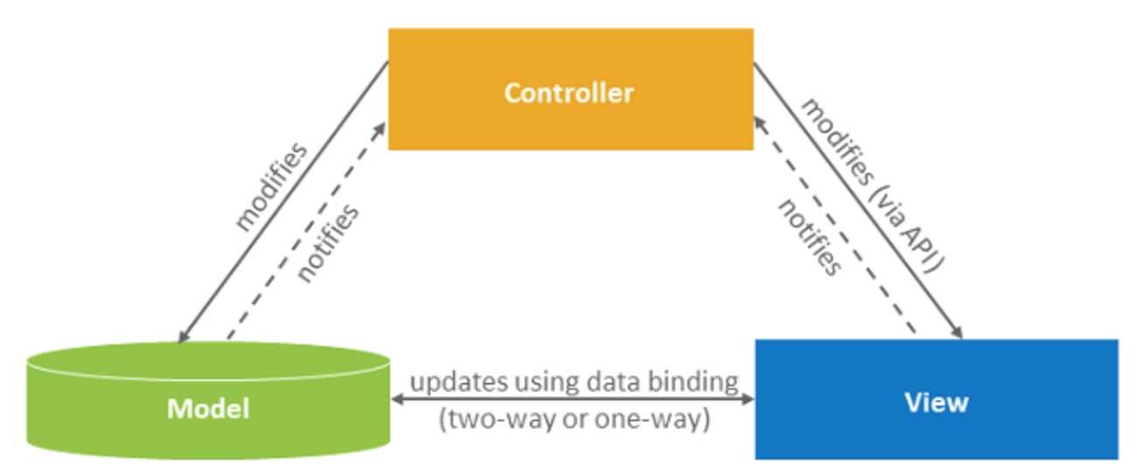

From this architecture, the system will consist of the customer (view), the manager (view), database(model). The controller will update any data that has been changed by both views to model, once the update is done the views will automatically update. With the three environments working together it creates a smooth application.

* + 1. Back End Components
       1. Firebase



* + - 1. SQLite DB Browser



* 1. Code Components of Client Application
     1. Activities
        1. AboutActivity.java
        2. BasketActivity.java
        3. HomeActivity.java
        4. LoginActivity.java
        5. MainActivity.java
        6. MenuDetailActivity.java
        7. MenuListActivity.java
        8. OrderPlacedActivity.java
        9. ProfileActivity.java
        10. ScanActivity.java
        11. SearchFoodActivity.java
        12. SeeReviewsActivity.java
        13. SignUpActivity.java
     2. Adapter
        1. BasketAdapter.java
     3. Config
        1. RemoteAPIService.java
        2. RetroClient.java
     4. Control
        1. Control.java
        2. Paypal.java
     5. Database
        1. Database.java
     6. Helper
        1. NotifyMeHelper.java
     7. Holder
        1. MenuHolder.java
        2. OrderHolder.java
        3. ProductHolder.java
        4. RestaurantHolder.java
        5. ReviewHolder.java
     8. Interaction
        1. FirebaseMessage.java
        2. FirebaseService.java
     9. Model
        1. MakeOrder.java
        2. Menu.java
        3. Notification.java
        4. Order.java
        5. Product_Type.java
        6. Response.java
        7. Restaurant.java
        8. Result.java
        9. Review.java
        10. Sender.java
        11. Token.java
        12. User.java
     10. View
  2. Code Components of Server Application
     1. Activities
        1. AboutActivity.java
        2. HomeActivity.java
        3. MainActivity.java
        4. MenuListActivity.java
        5. OrderDetailActivity.java
        6. OrdersPlacedActivity.java
     2. Adapter
        1. ExtraDetailAdapter.java
     3. Config
        1. RemoteAPIService.java
        2. RemoteClient.java
     4. Control
        1. Control.java
     5. Helper
        1. NotifyMeHelper.java
     6. Holder
        1. MenuHolder.java
        2. OrderHolder.java
        3. ProductHolder.java
     7. Interaction
        1. FirebaseMessage.java
        2. FirebaseService.java
     8. Model
        1. MakeOrder.java
        2. Menu.java
        3. Notification.java
        4. Order.java
        5. Product_Type.java
        6. Response.java
        7. Result.java
        8. Sender.java
        9. Token.java
        10. User.java
     9. View